Our Planet, Our Responsibility

*"Act Now, Save Our Future!"*

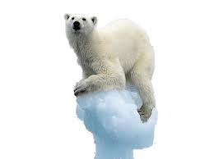**Join the Fight Against Climate Change**